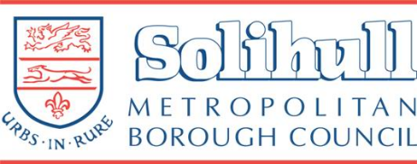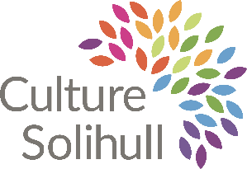

Community Artist in Residence
Solihull Borough Council

Project Summary
Solihull Council Cultural Services are seeking to commission 6 x Community Artists in Residence who would work with and alongside specific communities in the Borough. The work of the Community Artists in Residence will ensure the development of arts and cultural activity for a wider range of communities of location across the Borough, helping to develop a wider offer on people’s doorsteps with a focus on communities outside of the town centre.

The project aims to:
- develop opportunities for communities to meet and engage in cultural activity.
- develop a richer cultural offer for the borough.
- allow more people to engage in cultural activity.
- support artists to develop their practice in facilitation.
- develop a network of Community Artists in Residence who can support one another to deliver the programme of work.
- increase shared understanding of our communities, how they access culture and what barriers stand in their way to accessing arts and culture.
- support the inclusion and integration agenda.
- develop opportunities to continue to raise awareness of the positive contributions that arts and culture can play in the lives of our residents.
- ensure that participants feel part of Solihull's cultural identity.

Commission Methodology
Solihull Council is seeking to commission 6 x Community Artists in Residence who would work with and alongside communities of location across the Borough.

The commissioners are looking for engagement to be a key focus of the work. The commission offers the opportunity to develop links with communities across Solihull, sharing, celebrating, and finding stories, ideas, and creative collaborations. We are looking for creative proposals that respond to the aims of the project.

We are looking for artists to suggest what they would do, where their work would be based and how they would engage with the local community.

Each Community Artist in Residence will receive a fee of £6000 with an additional budget for resources.

Work should take place between June 2024 – December 2024.

Application Process
To be considered for the commissions, applicants must provide a proposal (expression of interest) in response to this brief, to be submitted by email to lisa.cleaver@solihull.gov.uk

Outline proposals must include a CV, examples of past work and a short statement of interest in response to the brief. Proposals should consider how you will approach the work and utilise the budget to fulfil the brief. Including: delivery days, format, and a rough resource budget.

We are interested in hearing from artists who are experienced in delivering work with communities. We are also interested in hearing from artists from the Borough who are new to or interested in developing a socially engaged practice and would welcome mentoring and /or support to deliver the project.

The expression of interest should be no more than 800 words.

Deadline for submission: Sunday 12th May 2024.

Selection Criteria
Community Artists in Residence will be selected based on their past work and on the response to the brief. The role will include:
- Experience of working alongside communities to develop and co-produce or an artist based in Solihull with a desire to develop a socially engaged community practice.
- Ability to work in conjunction with Solihull Council staff to identify, contact and liaise with Borough residents.
- Liaise with other freelancers and artists working on the project.
- To develop concepts, ideas, and proposals in collaboration with communities
- To ensure the project can be realised within budget and timescale.
- On completion, agree to input into an evaluation report.

The Community Artist in Residence will manage their own workload, priorities and deliver project administration effectively. It is essential that they are ICT literate, have their own computer, and self-sufficient in office administration.

This role is subject to a Disclosure Barring Service (DBS) check and two satisfactory references.
The freelancer or company appointed will be responsible for their own public liability insurance.

Commissioning Process
Stage 1 – Proposals submitted.
Stage 2 – Proposals shortlisted.
Stage 3 – Shortlisted applicants invited to present their ideas to a selection panel which will award the final commission.
Stage 4 – Delivery June 2024 – December 2024.

Selection Panel:
The selection panel will include:
- Solihull Council staff
- Local councillors
- Community representatives

Budget
The fee for the full commission is £6,000 x 6.
An additional budget is available to for each commission to realise activity.
The above fee is exclusive of any VAT, and this should be added if applicable.

Evaluation
Solihull Council will support the Community Artists in Residence to produce an evaluation framework, including gathering feedback from the selection panel and community. A detailed record of the project will be produced for future reference to include a project overview, successes, challenges/lessons learned and a photographic record of the project process and completion. This information will be made available on request to help promote the successes of the project and share learning from the process.

Agreement
The Community Artist in Residence agreement will set out:
• definition of involved parties, names, and addresses
• details of the commission
• confirmation of budget, fees, and methods of payment
• overall timetable stages and schedule of work
• agreement of roles and responsibilities of both parties
• delivery of work and insurance requirements
• copyright, reproduction rights, credits, and moral rights
• termination of agreement
• disputes procedure

Contact
Lisa Cleaver, Cultural Development Officer lisa.cleaver@solihull.gov.uk 0121 704 6996

