

The Studio at The Core Theatre,

Theatre Square, Homer Road,

Solihull B91 3RG

Studio Hire Information

The Core Theatre (formerly Solihull Arts Complex) is a popular town centre venue comprising Theatre (336 seats) Studio (multi-use up to 148), Courtyard Gallery, Encore eatery and Box Office facility.

The venue provides a programme of professional events and exhibitions and is also available for hire by individuals, groups, or professional promoters.

HIRE COSTS
Your hire period is per session.

Studio | LOCAL RATE | COMMERCIAL HIRE CHARGE
Session Hire* | 2025/26- £459  2026/27 - £482 | 2025/26- £695  2026/27 - £730

Please note the Studio hire charges quoted are non-vatable, however if your event is a performance or requires technical support it will be subject to VAT at 20%

Hire charges subject to change 1st April each year

*STANDARD SESSION TIMES
9am - 1pm or 1.30pm - 5.30pm or 6pm - 11pm

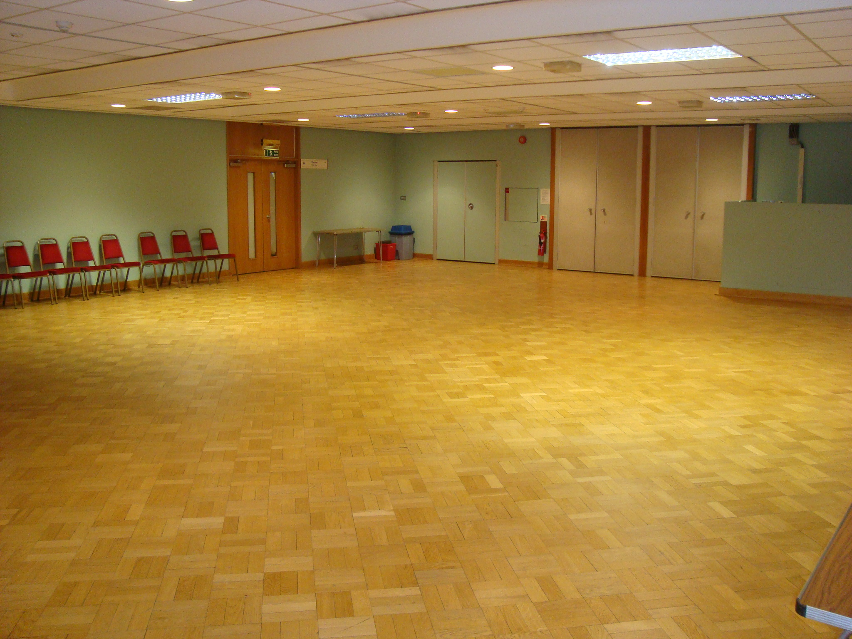

EQUAL OPPORTUNITIES
Solihull MBC is committed to equality of opportunity and operates an Equal Opportunities Policy. It is the policy of the Council to ensure that we treat all sectors of the community fairly and with dignity and respect.

We do not expect all organisations using our premises to have an equal opportunities policy; however we would expect that whilst using our premises all Hirers comply with that of Solihull MBC. Our premises will not be hired to any group or organisation that does not subscribe to the Council’s policy on equal opportunities.

HIRERS CANCELLATION POLICY
Booking cancelled within three months Hirer is liable for entire hire fee but no equipment
prior to date of event. charges. (Specially ordered/printed items will require full payment where non-returnable).

Booking cancelled between three months Hirer is liable for 50% of entire hire fee but no
and six months prior to date of event. equipment charges. (Specially ordered/printed items will require full payment where non-returnable).

Booking cancelled over six Hirer will lose deposit paid but incur no further
months prior to date of event. costs. (Specially ordered/printed items will still require full payment where non-returnable) or deposit transferred to alternative, new or existing booking.

*Deposits can be transferred only once, second cancellations incur loss of full deposit.

CONTACT US

If you wish to discuss a new or existing booking at The Core Theatre please do not hesitate to contact the appropriate section. All extensions have answer phones.

Venue Hire Enquiries 0121 704 6754/6961
Technical 0121 704 6754
Marketing 0121 704 6979
Encore (Catering enquiries) 0121 704 6813
Box Office 0121 704 6962
Or e-mail: hirethevenue@solihull.gov.uk

