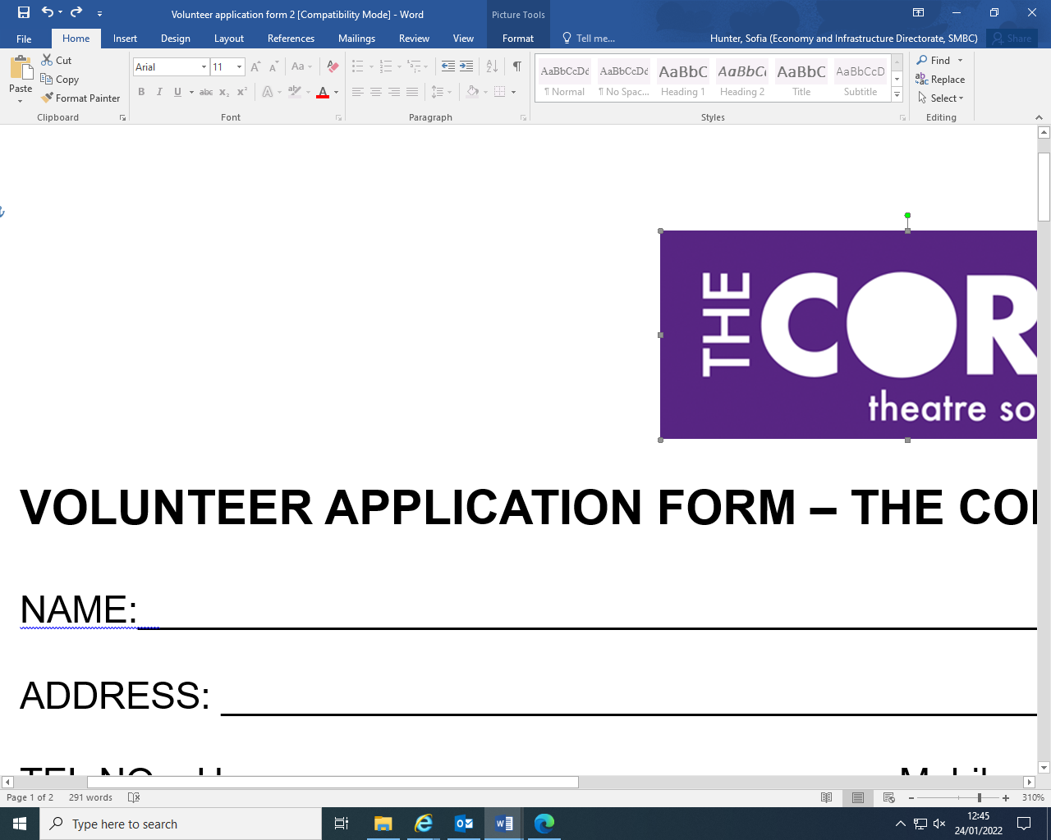


VOLUNTEER APPLICATION FORM – THE CORE
NAME: ____________________________________________________________________________

ADDRESS: _________________________________________________________________________

TEL NO: Home_____________________________Mobile___________________________________

E-MAIL: ___________________________________________________________________________

Are you in good health? Yes No give details overleaf. Do you have a disability? Yes No

Emergency Contact: Name: _______________________________Tel: _________________________

Please describe any relevant qualifications, skills and experience you have and also, tell us briefly why
you’d like to volunteer with us. If you have a CV, please attach this to this application.
_____________________________________________________________________________________
____________________________________________________________________________________________________________________________________________________________________________________________________________________________________________________________________________________________________________________________________________________

We need to know when you can volunteer – let us know your typical availability by ticking the days below.

Shifts | Mon | Tues | Wed | Thurs | Fri | Sat | Sun
Daytime
Evening

Do you have a criminal record? Yes No A ‘Yes’ answer will not necessarily mean your application will be rejected.

Please note: Successful volunteers may be required to apply for an enhanced disclosure from the Disclosure and Barring Service (Further details can be found at www.crb.gov.uk).
SMBC will organise this application.

Would you be willing for your personal details to be recorded on the SMBC database?
Any information supplied would be treated as confidential and not divulged to any third parties.
Yes No

Please supply details of two references, and note how you know them – please don’t use relatives:

REFEREE 1) ____________________________ REFEREE 2) _____________________________

How do you know them? ___________________ How do you know them? ____________________

Telephone #: ____________________________ Telephone #: ____________________________

_______________________________________ _______________________________________

Email: _________________________________ Email: __________________________________

_______________________________________ _______________________________________

Continued.../
Continuation page and further details

Relevant qualifications, skills and experience etc.

What do you hope to get out of volunteering with us?

Any other information (including health issues that we may need to be aware of) ...


Please return this form and any other relevant information to: Felicity Page, The Core Manager, Solihull Core Theatre, Homer Road, Solihull B91 3RG or email in to thecoretheatre@solihull.gov.uk.

